LP3 Group C Assignment 1 Screenshots

Metamask Website.

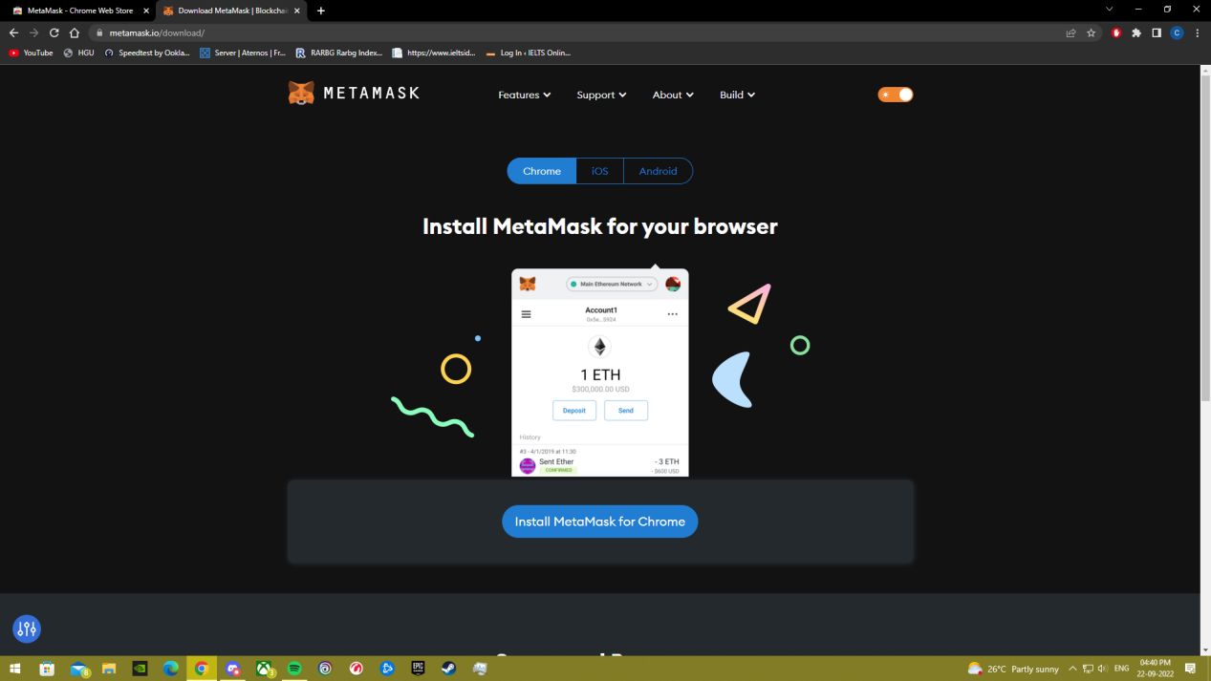

Adding Metamask as a Chrome Extension.

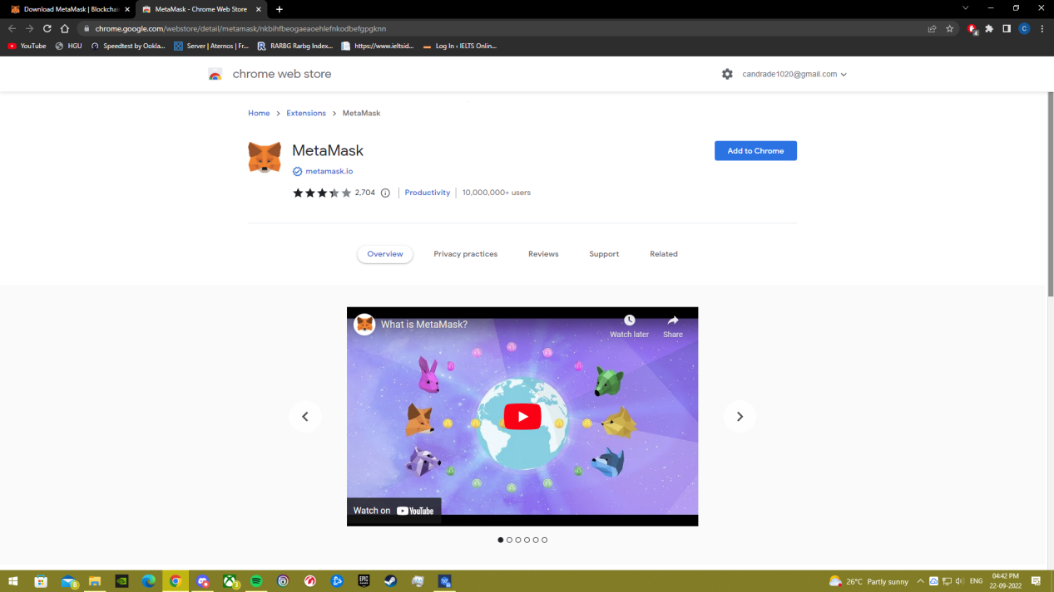

Metamask Chrome Extension Installed!

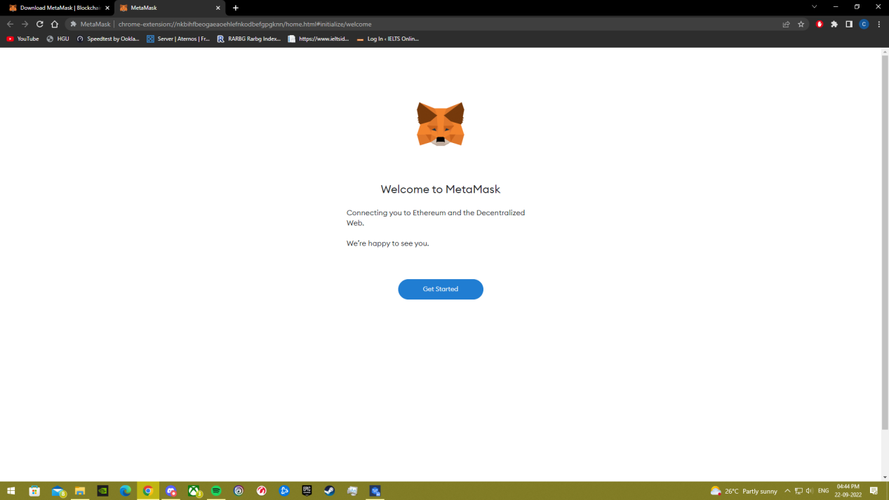

Agreeing to Terms and Conditions.

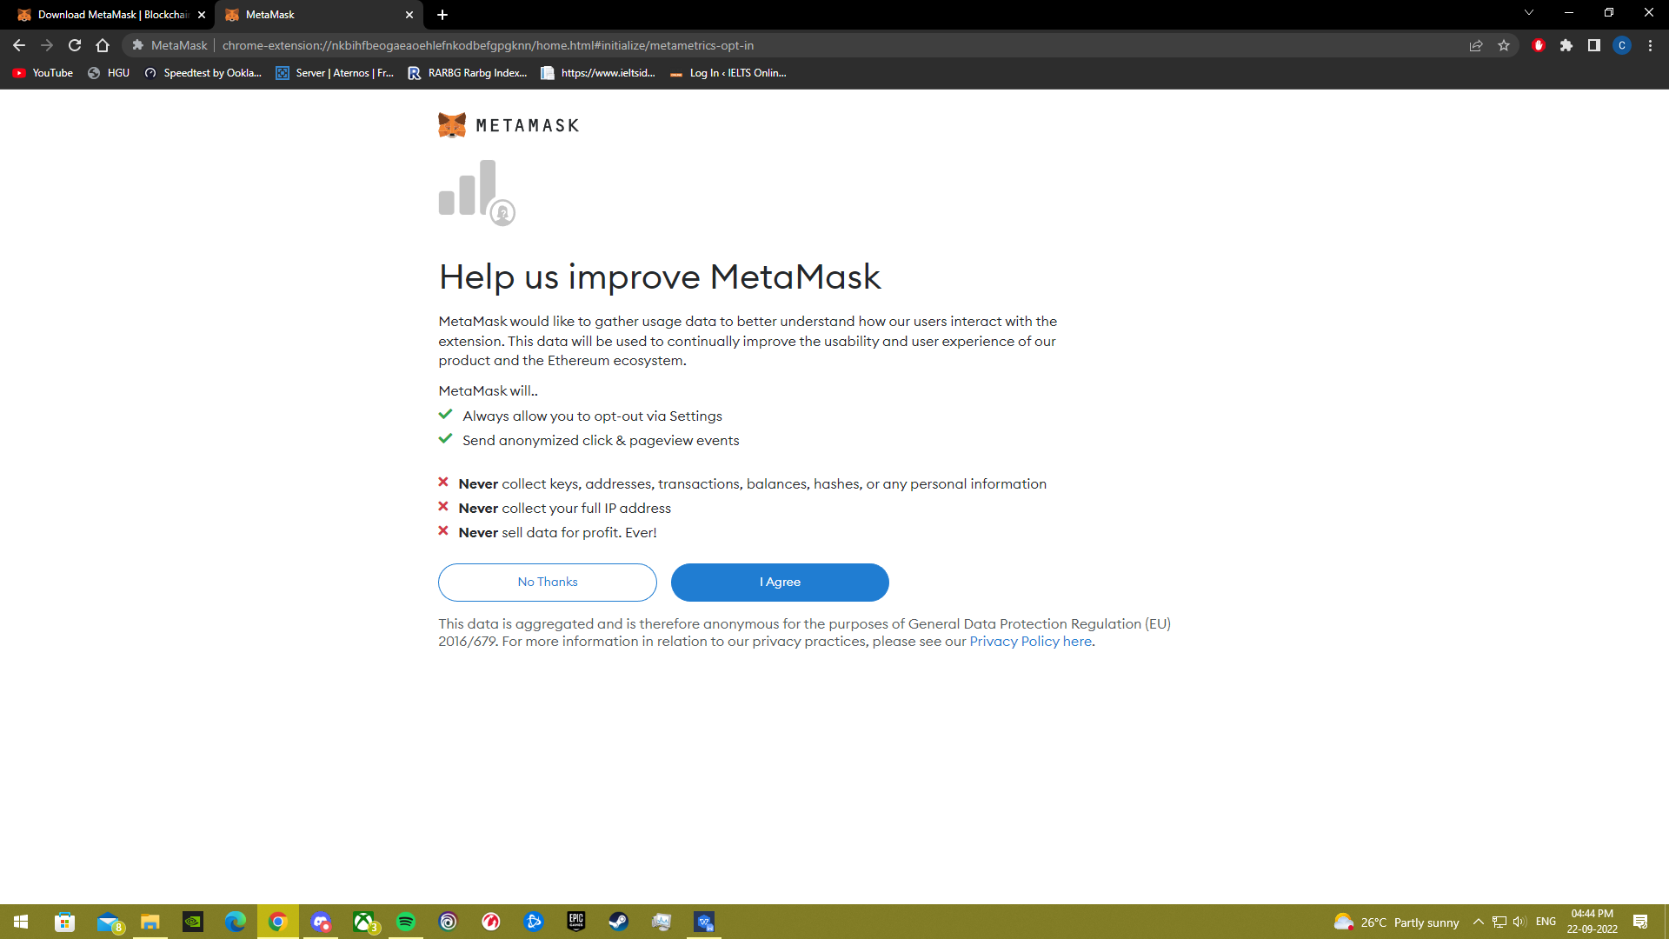

Metamask is installed and ready to use.

